**JUNIPER-CISCO BGP LAB**

**Network Topology:**

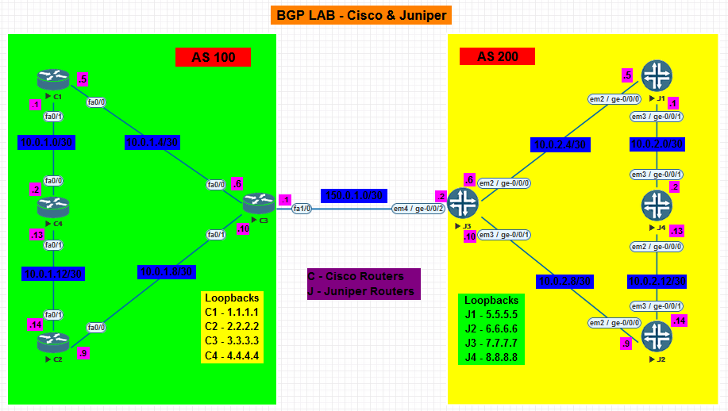

**NOTE: Perform all the basic configuration on Juniper Router given in Juniper Static Routing Lab before performing the lab**

* **In the above given Topology, 4 Cisco Routers belong to AS 100 and 4 Juniper Routers belong to AS 200.**
* **OSPF is running internally and separately in both the Autonomous Systems.**
* **C4 in AS 100 and J4 in AS 200 are non BGP routers only running OSPF.**

1. **Configure the respective physical interfaces & also configure the loopback interfaces on all the routers in the configuration mode as per the network topology.**

**CISCO Routers:**

**C1:**

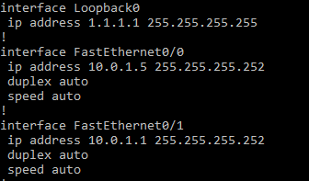

**C2:**

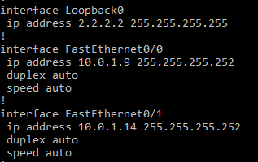

**C3:**

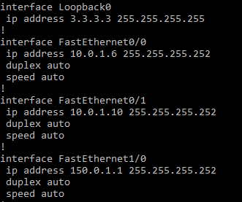

**C4:**

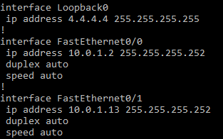

**JUNIPER Routers:**

**J1:**



**J2:**



**J3:**

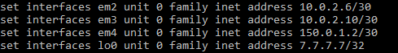

**J4:**



1. **Verify the interfaces on all the Cisco and Juniper routers.**

**CISCO Routers:**

**C1:**

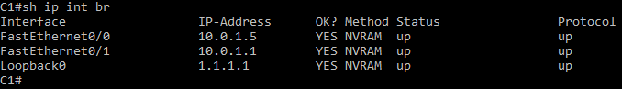

**C2:**

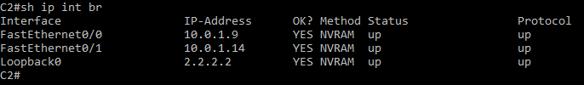

**C3:**

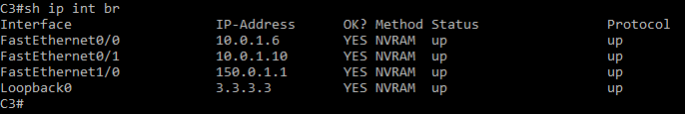

**C4:**

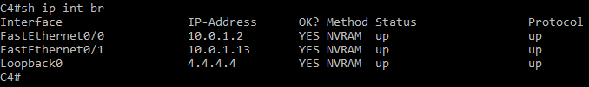

**JUNIPER Routers:**

**J1:**



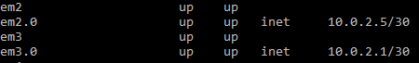



**J2:**



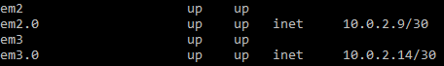



**J3:**



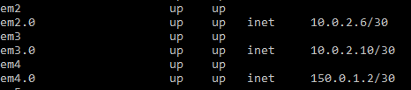



**J4:**



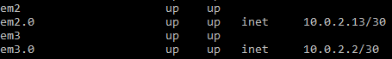



1. **Configure OSPF separately for Cisco routers in AS 100 as well as for Juniper routers in AS 200.**

**CISCO Routers:**

**C1:**

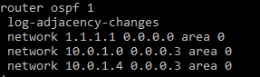

**C2:**

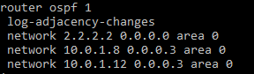

**C3:**

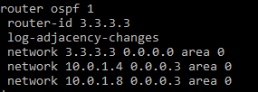

**C4:**

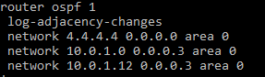

**JUNIPER Routers:**

**J1:**



**J2:**



**J3:**



**J4:**



1. **Verify OSPF neighborship on all the Routers.**

**CISCO Routers:**

**C1:**

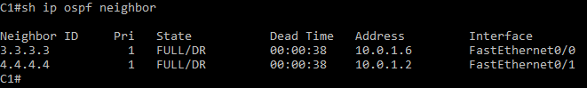

**C2:**

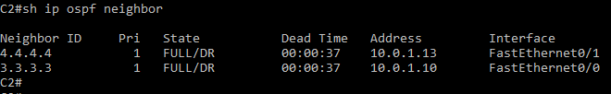

**C3:**

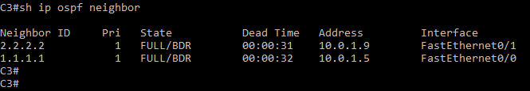

**C4:**

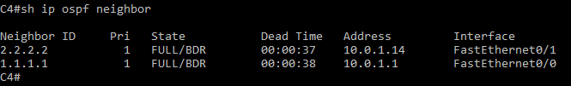

**JUNIPER Routers:**

**J1:**

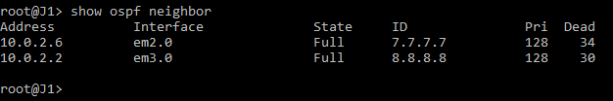

**J2:**

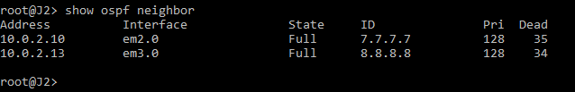

**J3:**

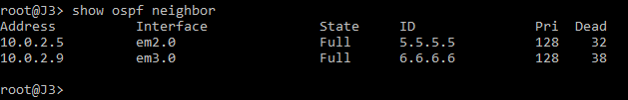

**J4:**

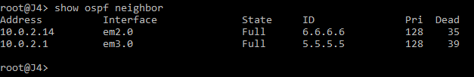

1. **Configure I-BGP in AS 100 between routers C1, C2 and C3. (Note: Do not configure BGP on C4).**

**CISCO Routers:**

**C1:**

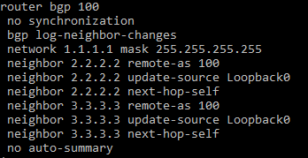

**C2:**

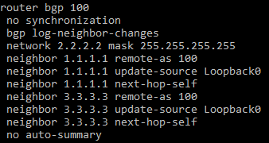

**C3:**

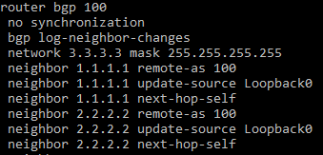**’**

1. **Verify I-BGP neighborship between above configured Routers.**

**CISCO Routers:**

**C1:**

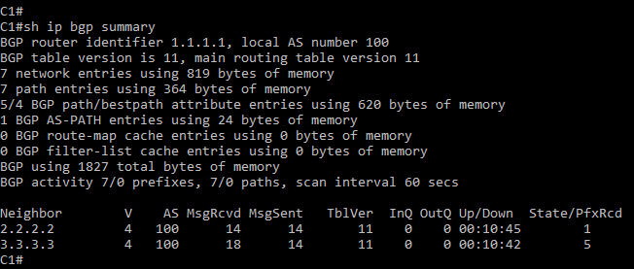

**C2:**

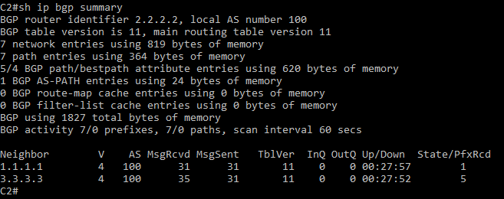

**C3:**

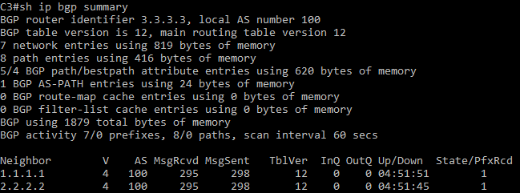

1. **Configure I-BGP in AS 200 between routers J1, J2 and J3.**

**JUNIPER Routers:**

**J1:**

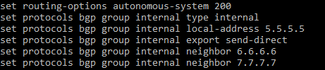

**J2:**

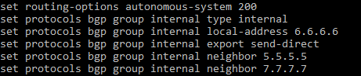

**J3:**

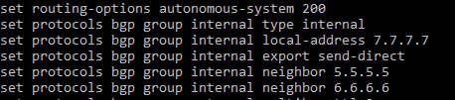

1. **Verify I-BGP neighborship between above configured Routers.**

**JUNIPER Routers:**

**J1:**

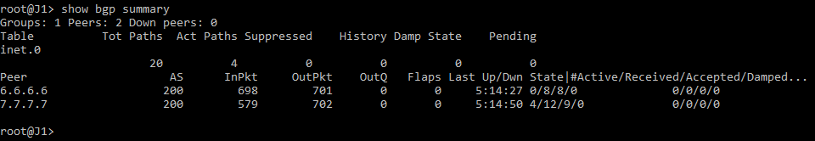

**J2:**

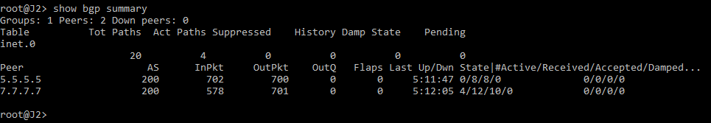

**J3:**

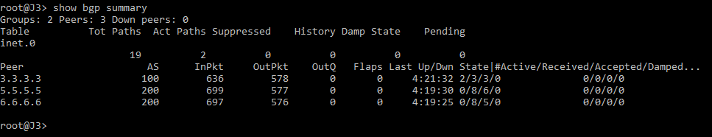

1. **Configure E-BGP neighborship between C3 and J3. Before that we need to configure Static Route on C3 and J3, giving the route to each other’s Loopback 0.**

**CISCO Routers:**

**C3:**



**JUNIPER Routers:**

**J3:**



**CISCO Routers:**

**C3:**

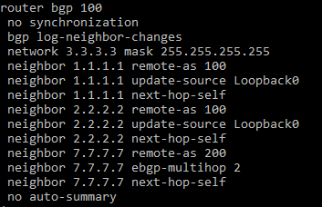

**JUNIPER Routers:**

**J3:**

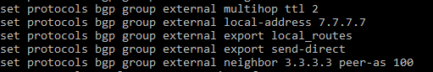

1. **Verify E-BGP neighborship between above configured Routers.**

**CISCO Routers:**

**C3:**

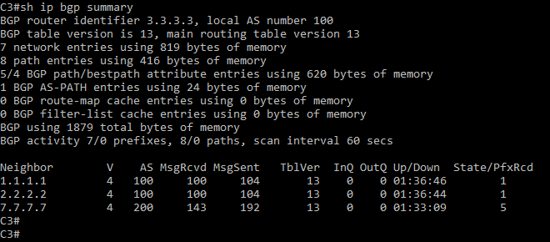

**JUNIPER Routers:**

**J3:**



1. **Configure policy options and policy statements on Juniper Routers.**

**JUNIPER Routers:**

**J1:**



**J2:**



**J3:**



1. **Verify routes in the routing Table for C1, C3, C4 and J1, J3, J4 routers.**

**CISCO Routers:**

**C1:**

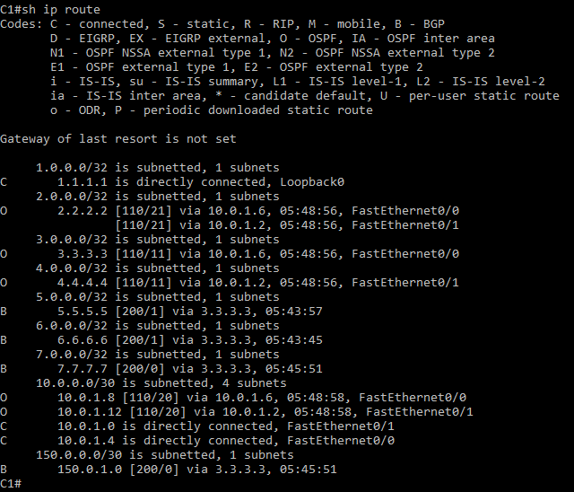

**C3:**

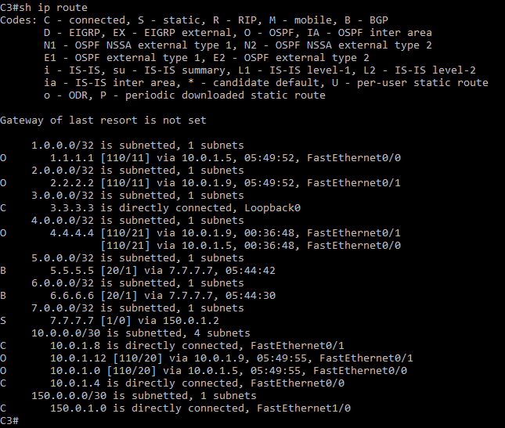

**C4:**

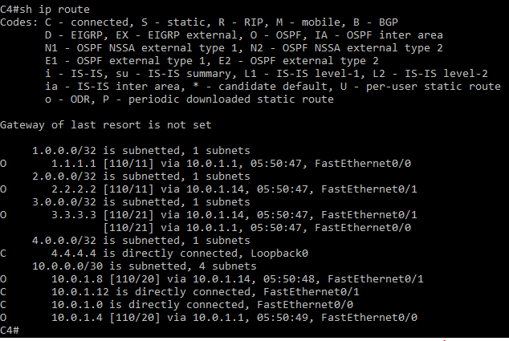

**JUNIPER Routers:**

**J4:**

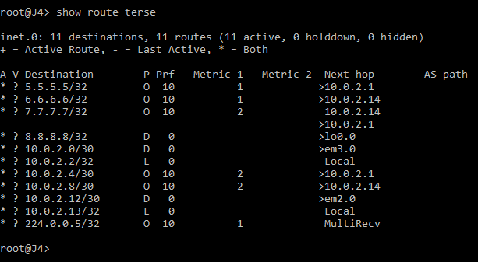

**J1:**

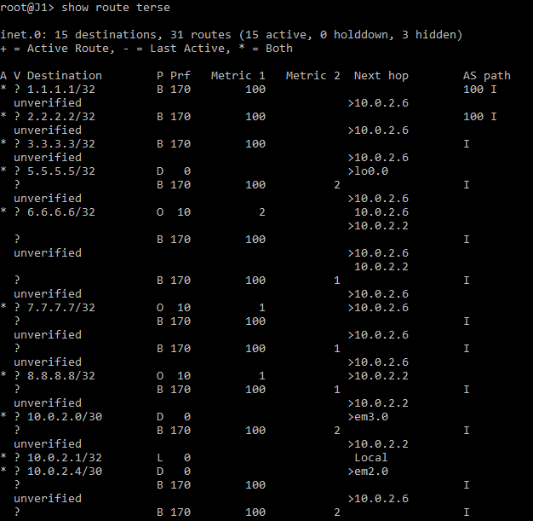

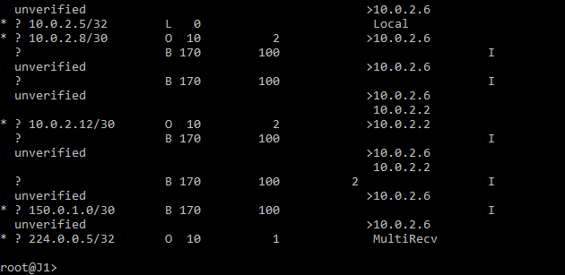

**J3:**

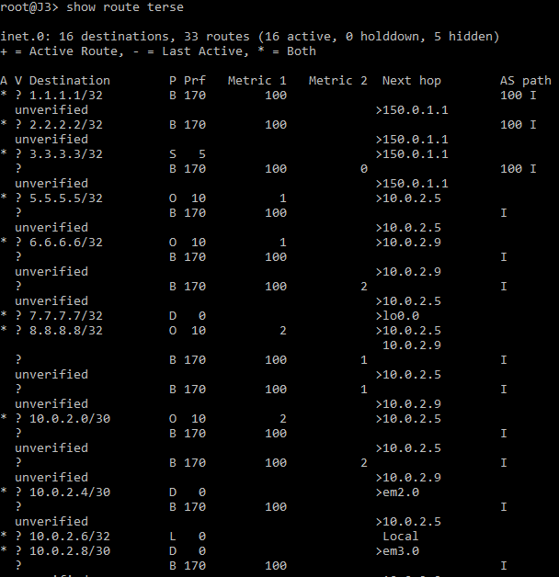

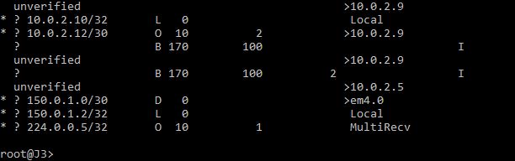

1. **Verifying connectivity between Cisco and Juniper Routers across the AS.**

**CISCO Routers:**

**C1:**

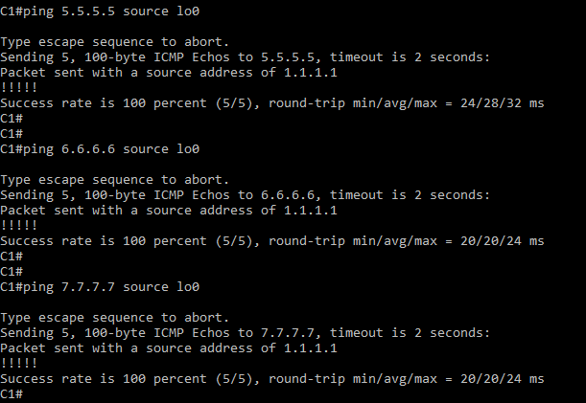

**C2:**

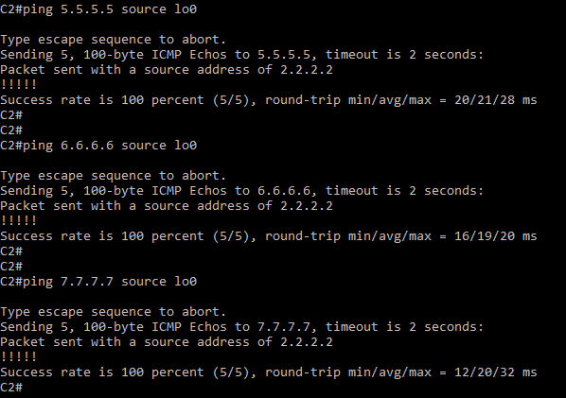

**JUNIPER Routers:**

**J1:**

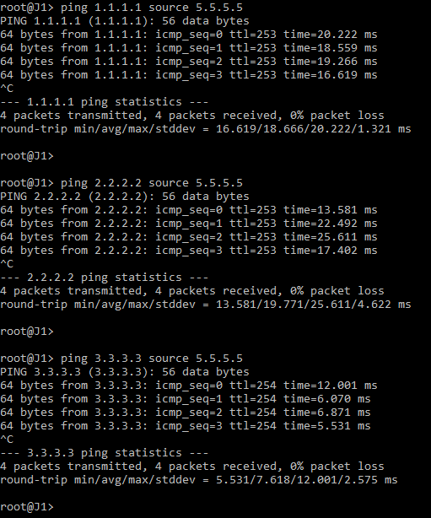

**J2:**

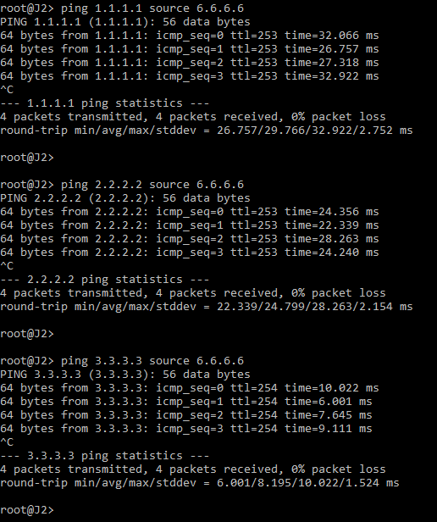

1. **Show entire configuration for Juniper routers. (display set command)**

**JUNIPER Routers:**

**J1:**

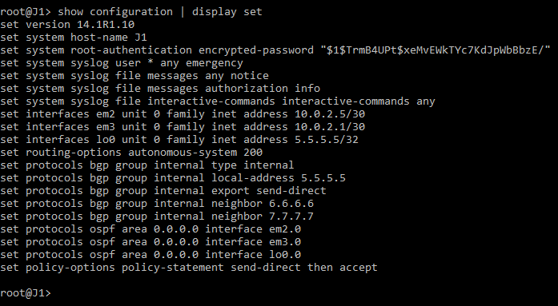

**J2:**

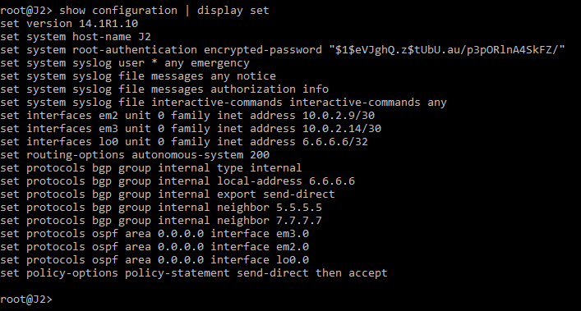

**J3:**

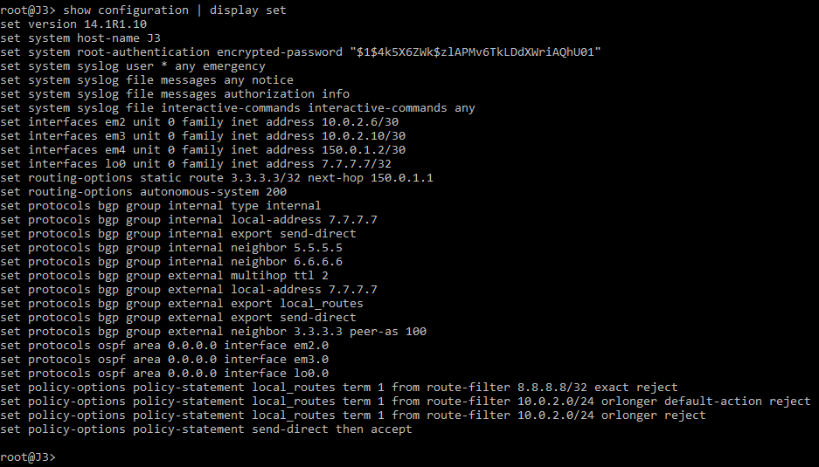

**J4:**

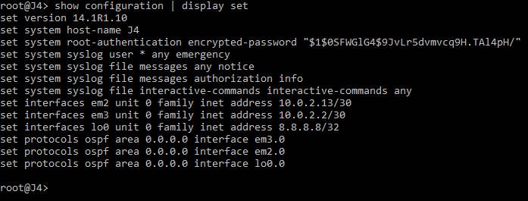

1. **Attach screenshot for show configuration of C3 and J3.**

**CISCO Routers:**

**C3:**

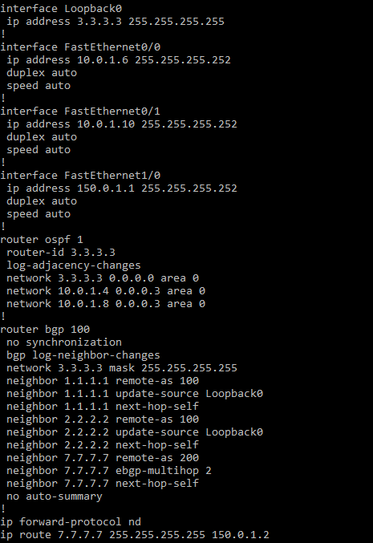

**JUNIPER Routers:**

**J3:**

